1. **Study the table provided below showing land area and population size for selected African countries and answer questions that follow.**

|  |  |  |
| --- | --- | --- |
| **COUNTRY** | **LAND AREA (000’km2)** | **POPULATION SIZE (‘000000s)** |
| **Algeria**  **Central African Rep.**  **Chad**  **Djibouti**  **Egypt**  **Ethiopia**  **Libya**  **Morocco**  **Niger**  **Somalia**  **Sudan**  **Tunisia** | **2,382**  **623**  **1,259**  **23**  **995**  **1,000**  **1,760**  **446**  **1,267**  **627**  **2,376**  **155** | **31**  **3.8**  **7.9**  **0.6**  **65.2**  **65.8**  **5.4**  **29.2**  **11.2**  **9.1**  **31.7**  **9.7** |

**Adopted: 2003 African Development inductors; World Bank, Washington D.C Pg.5**

1. **Calculate the population density for each of the selected countries shown in the table (06 mark)**
2. **Using the base map provided, draw a choropleth (density) map to represent the information obtained in (a) above. (06 marks)**
3. **Outline the merits and demerits of the statistical method used in (b) above (03 marks)**
4. **Explain the causes of the variations in the population density of the region shown on the base map. (10 marks)**

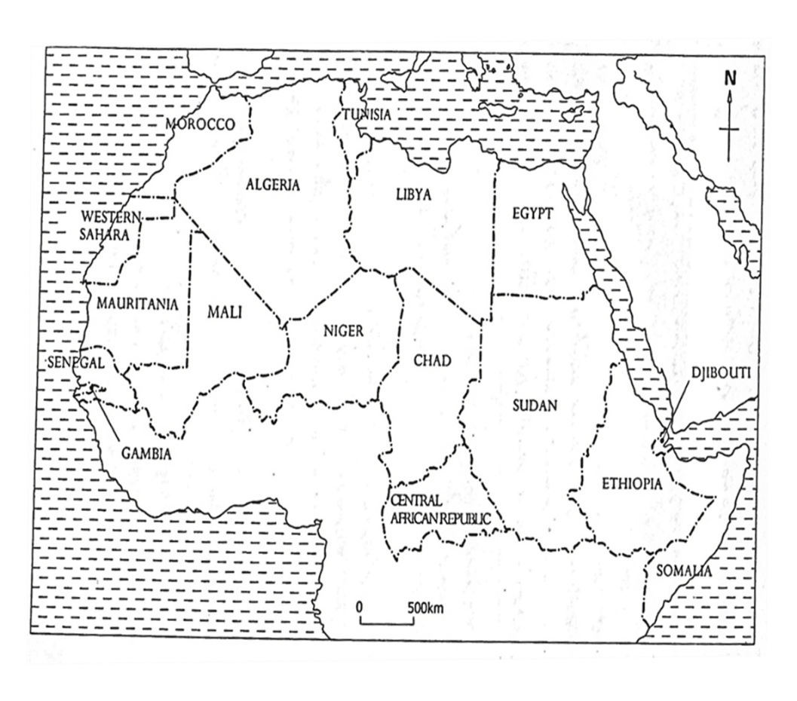

1. **Study the table below showing population size for selected African countries and answer the questions that follow:**

**Population size for selected countries in Africa.**

|  |  |
| --- | --- |
| **COUNTRY** | **POPULATION SIZE (000s)** |
| **ANGOLA Study** | **13936** |
| **BOTSWANA** | **15 64** |
| **DRC** | **54275** |
| **LESOTHO** | **2076** |
| **MALAWI** | **11828** |
| **MOZAMBIQUE** | **18986** |
| **NAMIBIA** | **1819** |
| **S AFRICA** | **44203** |
| **ZAMBIA** | **10872** |
| **ZIMBABWE** | **13076** |

**a) Using dot map statistical method, represent the information given in the table on the base map provided on the next page.**

**b) Outline the merits and demerits of using the method in (a) above.**

**c) Account for the variations in population distribution in the region shown on the map**

**d) For either DRC or South Africa, explain the implications of having a large population structure.**

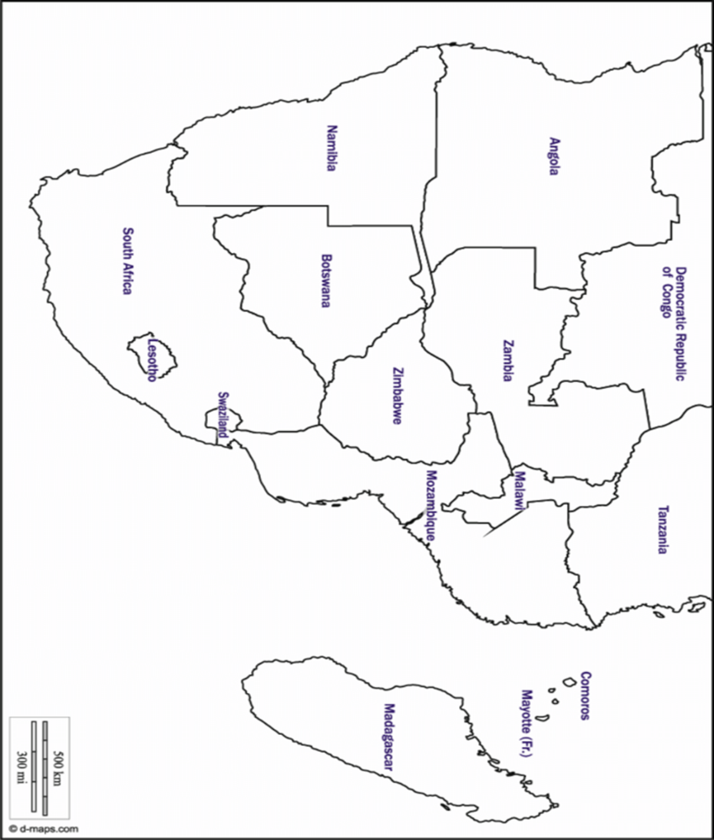

**3. Study the table given below and answer the questions that follow**

**Total exports from Uganda between 2000 and 2002(000) in US dollar.**

|  |  |  |
| --- | --- | --- |
| **Export to** | **2000** | **2002** |
| **Kenya** | **62947** | **61504** |
| **Tanzania** | **5487** | **5774** |

**(a)Draw a sketch map of Uganda and its neighboring countries and a flow map to represent the information contained in the table.**

**(b)Calculate the percentage change in the value of exports to;**

**i) Kenya,**

**ii) COMESA between 2000 and 2002.**

**(c) Account for the change in the value of exports obtained in (b) above.**

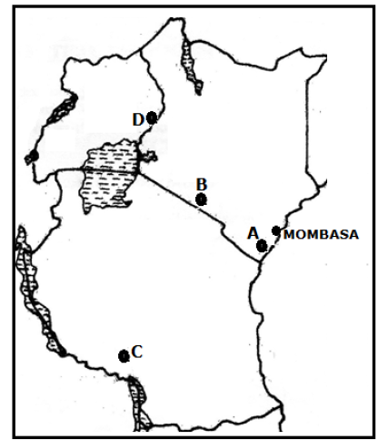

1. **Study the population demography of selected china’s provinces and answer the questions that follow**

|  |  |  |
| --- | --- | --- |
| **Province** | | **Population by 2021** |
| **Henan** | | **92,430,000** |
| **Shandong** | | **87,850,000** |
| **Sichuan** | | **84,300,000** |
| **Xinjiang** | | **17,180,000** |
| **Guangdong** | | **70,510,000** |
| **Xinjiang** | | **17,180,000** |
| **Hunan** | | **64,650,000** |
| **Tibet** | **2,480,000** |
| **Hubei** | **58,730,000** |
| **Qinghai** | **4,960,000** |
| **Zhejiang** | **44,350,000** |
| **Inner Mongolia** | **23,260,000** |
| **Gansu** | **24,940,000** |
| **Heilongjiang** | **37,510,000** |
| **Jilin** | **26,280,000** |

**a) Using the base map provided, draw a choropleth (density) map to represent the information obtained in (a) above. (06 marks)**

**b) Outline the merits and demerits of using the method above. (05 marks)**

**c) Account for the variation in population distribution in China. (08 marks)**

**d) Explain the implication of a large population to china. (07 marks)**

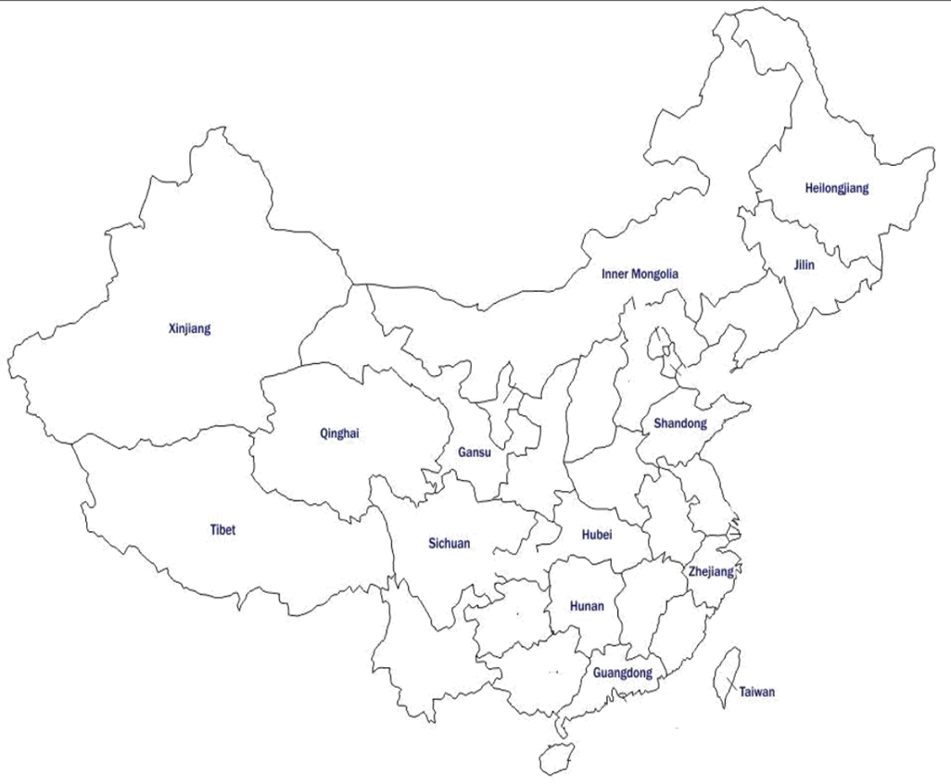

1. **Study the table below showing provincial land area under crop cultivation in South Africa and answer the questions that follow.**

|  |  |
| --- | --- |
| **Provinces** | **Area in sq. km** |
| **Cape Province** | **950000** |
| **Transvaal** | **540000** |
| **Orange Free State** | **250000** |
| **Natal** | **369000** |

1. **Using the base map provided below, draw a repeated symbol method showing the data above**
2. **Outline the demerits of using the above method**
3. 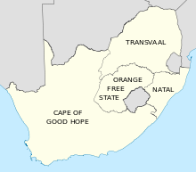**Assess the importance Large scale crop cultivation in the development of the Republic of South Africa**
4. **Study the table below showing population size in the provinces of the Republic of South Africa by 2017 and answer the questions that follow**

|  |  |
| --- | --- |
| **PROVINCES** | **Population in millions** |
| **Northern Cape** | 1.2 |
| **Free State** | 2.9 |
| **North West** | 3.9 |
| **Mpumalanga** | 4.4 |
| **Limpopo** | 5.8 |
| **Eastern Cape** | 6.5 |
| **Western Cape** | 6.5 |
| **KwaZulu-Natal** | 11.1 |
| **Gauteng** | 14.3 |

1. **Using the base map provided below, draw proportional squares showing the data above**
2. **i) Outline the demerits of using the above method.**

**ii) Calculate the:**

* **Percentage population of Gauteng province.**
* **Total population in Republic of South Africa**

1. **Examine the factors causing a large population size in Republic of South Africa**
2. **Outline the importance of a large population size in Republic of South Africa**

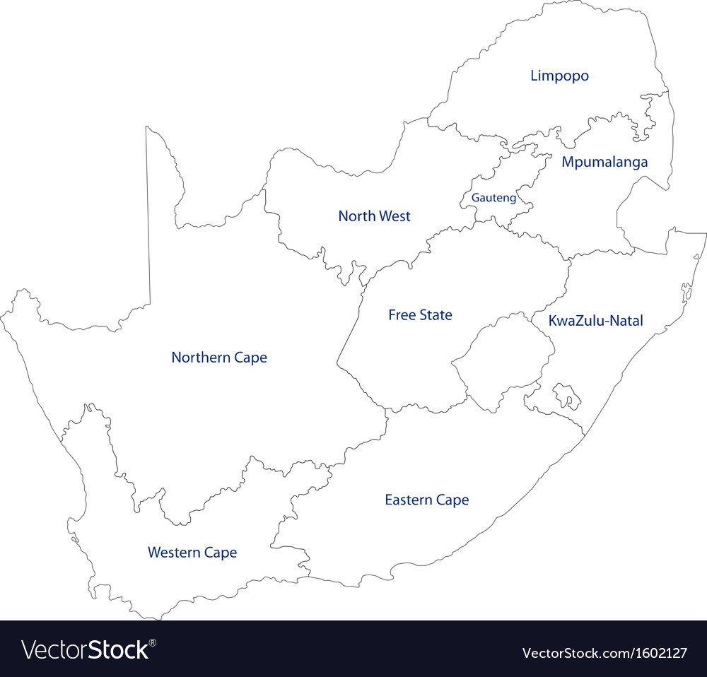

1. **Study the table below showing population size in the provinces of the Republic of South Africa by 2017 and answer the questions that follow**

|  |  |  |
| --- | --- | --- |
| **PROVINCES** | **Population in millions** | |
| **Northern Cape** | 1.2 | 1.4 |
| **Free State** | 2.9 | 3.2 |
| **North West** | 3.9 | 4.5 |
| **Mpumalanga** | 4.4 | 4.7 |
| **Limpopo** | 5.8 | 6.0 |
| **Eastern Cape** | 6.5 | 6.9 |
| **Western Cape** | 6.5 | 7.1 |
| **KwaZulu-Natal** | 11.1 | 11.6 |
| **Gauteng** | 14.3 | 15.5 |

1. **Using the base map provided below, draw proportional divided circles showing the data above**
2. **i) Outline the demerits of using the above method.**

**ii) Calculate the:**

* **Percentage population of Gauteng province.**
* **Total population in Republic of South Africa**

1. **Examine the factors causing a large population size in Republic of South Africa**
2. **Outline the importance of a large population size in Republic of South Africa**



1. **Study the table below showing marine fish production in the major fishing grounds of the world (2019) and answer the questions that follow**

|  |  |
| --- | --- |
| **Major Fishing Grounds of the World** | **Marine Fish Production** |
| **Southern Ocean** | **9,000,000** |
| **Atlantic ocean** | **8,900,000** |
| **Arctic Ocean** | **2,500,000** |
| **Pacific Ocean** | **6,500,000** |
| **Indian Ocean** | **3,560,000** |
| **East china sea** | **10,440,000** |
| **TOTAL PRODUCTION** | **40,900,000** |

1. **Using the base map provided below, draw proportional circles showing the data above**
2. **i) Outline the merits of using the method above**

**ii) Name the:**

* **Leading fishing ground in the table above**
* **Most fishing country in the fishing ground named above**

1. **For either Pacific fishing ground or Atlantic fishing ground, account for the large scale fish Production in 2019.**
2. **Explain the importance of fishing sector to the development of the region.**

East China Sea

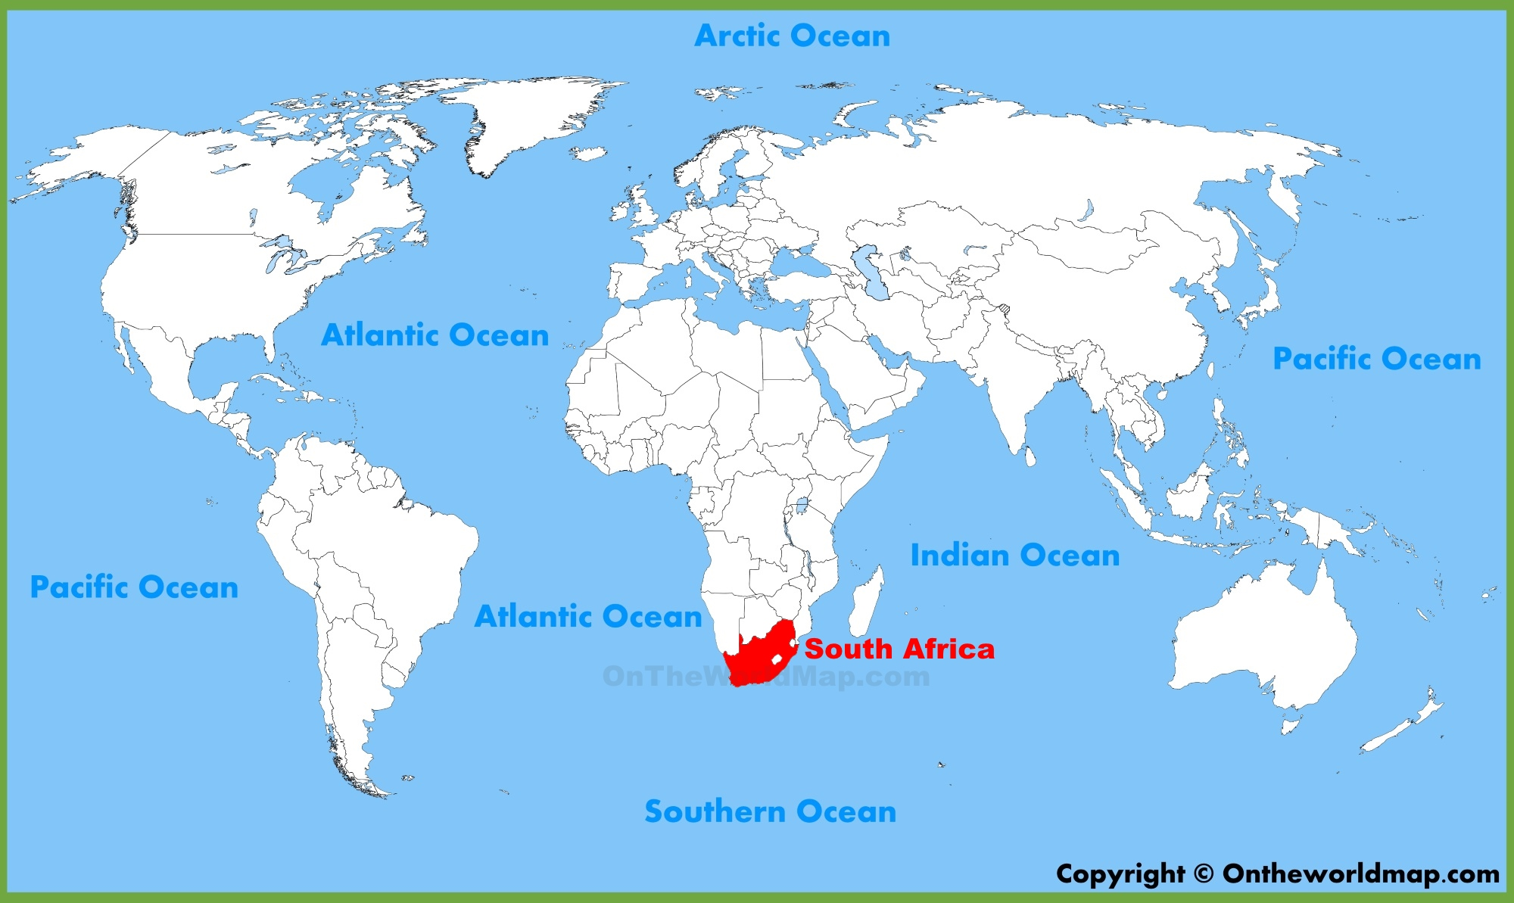

1. **Study table I below showing Kenya’s inbound tourists from the different continents in 2019 and answer the questions that follow:**

**Table I**

|  |  |
| --- | --- |
| **CONTINENT** | **NUMBER OF INBOUND TOURISTS (‘000’)** |
| **NORTH AMERICA** | **24,600** |
| **ASIA** | **24,000** |
| **EUROPE** | **12,900** |
| **AUSTRALIA** | **30,900** |
| **SOUTH AMERICA** | **41,600** |

***Adapted: Kenya – Tourism sector performance report 2019.***

1. **Using the flow diagram (Map) statistical method, represent the information given in table I on the base line map provided. (08 marks)**
2. **Outline the demerits of using the statistical method in (a) above. (03 marks)**
3. **Comment on Kenya’s inbound tourists from the different continents in 2019. (04 marks)**
4. **Explain the impact of the inbound tourism on the environment of Kenya. (10 marks)**

